**CHANDIGARH UNIVERSITY**

UNIVERSITY INSTITUTE OF ENGINEERING

**DEPARTMENT OF COMPUTER SCIENCE & ENGINEERING**



|  |  |
| --- | --- |
| **Submitted By:                                                                          Submitted To:**  Yash Gupta ER. Monika(E12802) | |
| **Subject Name** | Design Analysis and Algorithm |
| **Subject Code** | 20CSP_312 |
| **Branch** | CSE |
| **Semester** | 5th |

**LAB -INDEX**

|  |  |  |  |  |  |  |  |
| --- | --- | --- | --- | --- | --- | --- | --- |
| **Sr.No** | **Program** | **Date** | **Evaluation** | | | | **Sign** |
| **LW(12)** | **VV(8)** | **FW(10)** | **Total (30)** |
|  |  |  |  |  |  |  |  |
|  |  |  |  |  |  |  |  |
|  |  |  |  |  |  |  |  |
|  |  |  |  |  |  |  |  |
|  |  |  |  |  |  |  |  |
|  |  |  |  |  |  |  |  |
|  |  |  |  |  |  |  |  |
|  |  |  |  |  |  |  |  |
|  |  |  |  |  |  |  |  |

**Experiment 3.2**

**1. Aim/Overview of the practical:**

Code and analyze to do a depth-first search (DFS) on an undirected graph. Implementing an application of DFS such as (i) to find the topological sort of a directed acyclic graph, OR (ii) to find a path from source to goal in a maze.

**2. Algorithm:**

DFS(G, u)

u.visited = true for each v  G.Adj[u] if v.visited == false

DFS(G,v)

init() {

For each u  G

u.visited = false

For each u  G

DFS(G, u)

}

**3. Steps for experiment/practical/Code:**

a) Code and analyze to do a depth-first search (DFS) on an undirected graph

#include<bits/std++.h>

using namespace std;

class Graph {

public:

map<int, bool>visited;

map<int,list<int>>adj;

void addEdge(int v, int w);

void DFS(int v);

};

void Graph::addEdge(int v, int w)

{

adj[v].push_back(w);

}

void Graph::DFS(int v)

{

visited[v] = true;

cout << v << " ";

list<int>::iterator i;

for (i = adj[v].begin();

i != adj[v].end(); ++i)

if (!visited[*i])

DFS(*i);

}

int main() {

Graph g;

g.addEdge(0, 1);

g.addEdge(0, 2);

g.addEdge(1, 2);

g.addEdge(2, 0);

g.addEdge(2, 3);

g.addEdge(3, 3);

cout << "Following is Depth First Traversal" " (starting from vertex 2) \n";

g.DFS(2);

return 0;

}

b) to find the topological sort of a directed acyclic graph

#include <bits/stdc++.h>

using namespace std;

class Graph {

int V;

list<int>* adj;

void topologicalSortUtil(int v, bool visited[ ], stack<int>& Stack);

public:

Graph(int V);

void addEdge(int v, int w);

void topologicalSort();

};

Graph::Graph(int V)

{

this->V = V;

adj = new

list<int>[V];

}

void Graph::addEdge(int v, int w)

{

adj[v].push_back(w);

}

void Graph::topologicalSortUtil(int v, bool visited[],stack<int>& Stack) {

visited[v] = true;

list<int>::iterator i;

for (i = adj[v].begin(); i != adj[v].end(); ++i)

if (!visited[*i])

topologicalSortUtil(*i, visited, Stack);

Stack.push(v);

}

void Graph::topologicalSort()

{

stack<int> Stack;

bool* visited = new bool[V];

for (int i = 0; i < V; i++)

visited[i] = false;

for (int i = 0; i < V; i++) if (visited[i] == false)

topologicalSortUtil(i, visited, Stack);

while (Stack.empty() == false){

cout << Stack.top() << " ";

Stack.pop();

} }

int main() {

Graph g(6);

g.addEdge(5, 2);

g.addEdge(5, 0);

g.addEdge(4, 0);

g.addEdge(4, 1);

g.addEdge(2, 3);

g.addEdge(3, 1);

cout << "Following is a Topological Sort of the given "

"graph \n";

g.topologicalSort();

return 0;

}

c) to find a path from source to goal in a maze.

#include <iostream>

#include <vector>

#include <climits>

#include <cstring>

using namespace std;

bool isSafe(vector<vector<int>> &mat, vector<vector<bool>> &visited, int x, int y)

{

return (x >= 0 && x < mat.size() && y >= 0 && y < mat[0].size()) && mat[x][y] == 1 && !visited[x][y];

}

void findShortestPath(vector<vector<int>> &mat, vector<vector<bool>> &visited, int i, int j, int x, int y, int &min_dist, int dist)

{

if (i == x && j == y)

{

min_dist = min(dist, min_dist); return;

}

visited[i][j] = true;

if (isSafe(mat, visited, i + 1, j)) {

findShortestPath(mat, visited, i + 1, j, x, y, min_dist, dist + 1);

}

if (isSafe(mat, visited, i, j + 1)) {

findShortestPath(mat, visited, i, j + 1, x, y, min_dist, dist + 1); }

if (isSafe(mat, visited, i - 1, j)) {

findShortestPath(mat, visited, i - 1, j, x, y, min_dist, dist + 1);

}

if (isSafe(mat, visited, i, j - 1)) {

findShortestPath(mat, visited, i, j - 1, x, y, min_dist, dist + 1);

}

visited[i][j] = false;

}

int findShortestPathLength(vector<vector<int>> &mat, pair<int, int> &src, pair<int, int> &dest)

{

if (mat.size() == 0 || mat[src.first][src.second] == 0 || mat[dest.first][dest.second] == 0){

return -1;

}

int M = mat.size(); int N = mat[0].size();

vector<vector<bool>> visited;

visited.resize(M, vector<bool>(N));

int min_dist = INT_MAX;

findShortestPath(mat, visited, src.first, src.second, dest.first, dest.second, min_dist, 0);

if (min_dist != INT_MAX) { return min_dist;

}

return -1;

}

int main()

{

vector<vector<int>> mat =

{

{ 1, 1, 1, 1, 1, 0, 0, 1, 1, 1 },

{ 0, 1, 1, 1, 1, 1, 0, 1, 0, 1 },

{ 0, 0, 1, 0, 1, 1, 1, 0, 0, 1 },

{ 1, 0, 1, 1, 1, 0, 1, 1, 0, 1 },

{ 0, 0, 0, 1, 0, 0, 0, 1, 0, 1 },

{ 1, 0, 1, 1, 1, 0, 0, 1, 1, 0 },

{ 0, 0, 0, 0, 1, 0, 0, 1, 0, 1 },

{ 0, 1, 1, 1, 1, 1, 1, 1, 0, 0 },

{ 1, 1, 1, 1, 1, 0, 0, 1, 1, 1 },

{ 0, 0, 1, 0, 0, 1, 1, 0, 0, 1 },

};

pair<int, int> src = make_pair(0, 0);

pair<int, int> dest = make_pair(7, 5);

int min_dist = findShortestPathLength(mat, src, dest);

if (min_dist != -1)

{

cout << "The shortest path from source to destination "

"has length " << min_dist;

}

else {

cout << "Destination cannot be reached from a given source";

}

return 0;

}

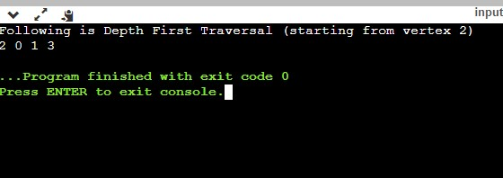**4. Result/Output/Writing Summary:**

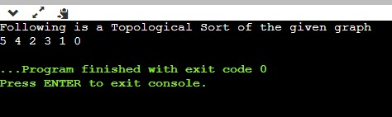

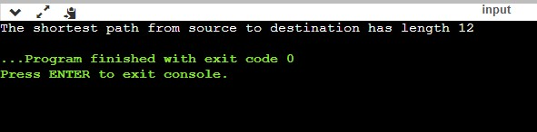

6. **Evaluation Grid (To be created as per the SOP and Assessment guidelines by the faculty):**

|  |  |  |  |
| --- | --- | --- | --- |
| Sr. No. | Parameters | Marks Obtained | Maximum Marks |
| 1. |  |  |  |
| 2. |  |  |  |
| 3. |  |  |  |